Financial Statement Consolidation
2022.08.04

This standard operating procedure will detail the process of taking completed financials and reconciliation details to organize and save in FileCabinet.

Any accounts where Tracy V. or Kristin S. is the L1 is out of scope currently for this process.

When bookkeeping is completed for the month and ready for review, ensure all reconciliations, payroll reports, and the 4 financials (1 BS, 3 P&Ls, see bottom of document) are saved within the client’s folder within the R: or Q/V drive. These documents will be merged together by an admin (Ryan W.) through her tools and saved in FileCabinet.

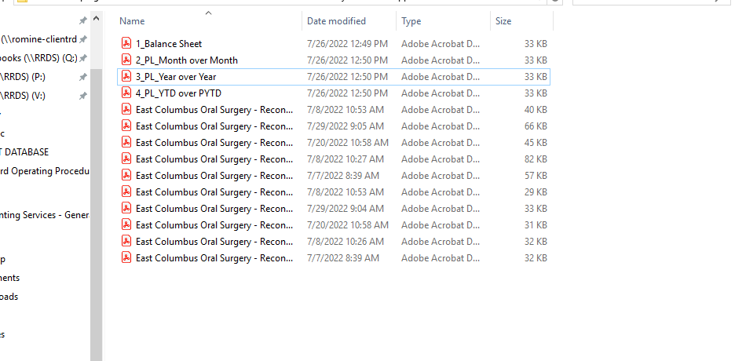

These files should be saved in the following location:
Client -> Documentation -> Monthly Financial Support -> Year.Month

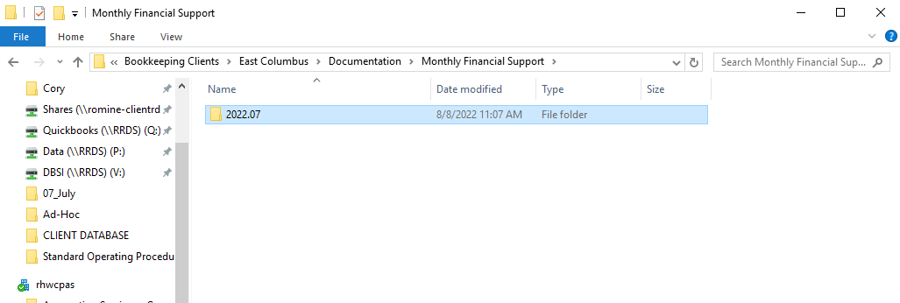

Once all files are saved within the client’s folder, please open a practice project and assign a “Compilation” project to Ryan Wilson to complete the consolidation. See screenshot below, all fields within the red boxes need completed. From there, she will save the support in FileCabinet and partner reviews can occur.

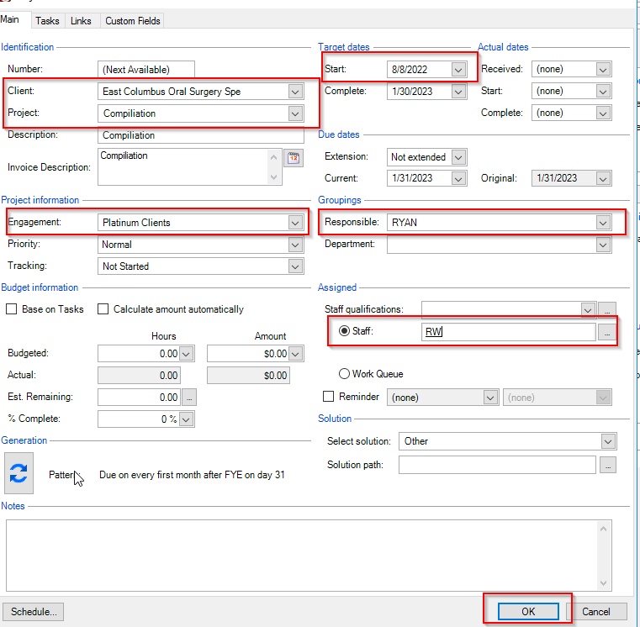

Our 4 financials and all reconciliations and supporting bank statements will need saved in FileCabinet prior to financial review with management, internal or external. The 4 financials need to be:
- Page 1: Balance Sheet versus prior month (along with $ variance)
- Page 2: P&L versus prior month (along with $ variance)
- Page 3: P&L versus prior year (along with $ variance)
- Page 4: P&L YTD versus prior YTD (along with $ variance)

